University of Stellenbosch: Department of History

History Essay Writing Guide

(Extracts of Tutorials conducted and compiled by Danielle Dunbar, Jennifer Muirhead, Dané van Wyk, Annemieke Nel in 2010)

Section A: Understanding Sources

Historical writing is based on evidence gained from historical sources. These sources are separated into two categories – primary and secondary sources.

Primary Sources

Primary sources are created at the time of the event being studied; they provide the researcher with firsthand experience of the historical event. There are many types of primary sources:

Documents and records
Government records, manifestos, church records, contracts, the minutes of meetings, maps and so on.
Surveys and reports
Censuses, tax inspections, and opinion polls etc.
Family and personal sources
Letters, diaries, postcards, memoirs, and oral histories etc.
Media and popular culture
Audio and visual recordings (like movies), advertisements, photographs, newspapers, magazines, and posters etc.
Physical artefacts
Archaeological findings, photographs, inscriptions, costumes etc.
Literary and artistic sources
Novels, poems, artworks and architecture.
Oral sources
Interviews, folk songs, popular songs, traditions, fairytales, myths etc.

It is important to note that a primary source does not have to be factually correct to be valuable. Primary sources offer the historian valuable insight into the mindset of people in the past. The historian needs to have a broader knowledge of the period to analyse primary sources, noting what may have actually happened against what people in the time thought was happening. In order to do this, historians compare primary sources against each other (where possible) and use whatever secondary material they can to give them a fuller understanding of the period or event that they are looking at.

Secondary Sources

Secondary sources synthesise and interpret primary materials to create an historical interpretation or argument of the past. It is important to note that the people who write secondary sources have been influenced by what has been written about the topic before them. As such they are removed from the actual historical event (i.e.: they are not writing at the time of the historical event). People without the necessary skills of analysing primary material, such as students, will make use of secondary sources to gain a broad understanding of a historical period or event. When reading secondary sources students should always bear in mind that the source is written by someone who has been influenced by the thinking of their time, and look out for the biases of the writer – as well as their own biases as readers. Secondary sources include history books, textbooks, journal articles, Internet articles, encyclopaedias etc.

A source can be both primary and secondary

Sources do not always fit neatly into these two categories, in fact a source can be primary or secondary depending on the how it is used. If a student is researching the South African War then a historical work like The South African War 1899-1902 by Bill Nasson (published in 1999) is a helpful secondary source (as it uses primary sources to give an interpretation of the historical event in question). However, if the student is researching the way in which the South African War has been interpreted by historians then Nasson’s book is a primary source (as it is an historian’s interpretation of the war). As such the status of a source as primary or secondary depends on the way in which it is used (i.e. the topic of historical study, the perspective/context of historical study, and the questions being asked).

Analysing Sources

As mentioned above sources, primary or secondary, need to be analysed carefully and compared to other sources. Often sources are inaccurate, biased or contradictory. It is the historian’s job to get as close as possible to what happened through the close examination of both primary and secondary sources. At undergraduate level students work almost exclusively with secondary material, learning to compare, summarise and synthesise these sources into an original argument. When examining sources students should ask the following questions:

- Who created the source and why did they create it? Was it created unconsciously and without planning, through a routine transaction, or through a calculated process? (For example, can you think how a textbook commissioned by the government of a country will differ from an historical work by a historian?)
- Did the recorder have direct knowledge of the event or did they report what others saw (i.e.: is the report primary or secondary?)
- Was the recorder a neutral party or did they have special interests which might have altered what was recorded? (for example, can you think how someone who was pro-Nazi might have recorded an event in World War Two compared to someone who was against the Nazis?)
- Did the recorder produce the source for personal use or for an audience? If so, for which audience? Did the recorder wish to inform others or persuade them of something? (For example, can you think of how someone might portray themselves in an autobiography written for mass consumption, and how they might portray themselves privately?)
- What arguments, ideas and values does the source reflect of the time period in which it is written? (For example, can you think of the differences in mindset of a writer in the early twentieth century and a writer today?)
Sources and essay writing

Students require sources in order to write a history essay. Special attention should be paid to the minimum requirement of sources (this minimum depends on the lecturer). If too few sources are used students will lose marks for sources as well as content. Students must also pay strict attention to the types of sources that they use. The two most fruitful sources at undergraduate level are books (found in the library) as well as journal articles (these can be found on the internet – e.g.: JSTOR, EBSCOhost and the Arts and Humanities Citation Index) or in the library (in the section that houses academic journals). Although journal articles can be found on the internet they do not count as internet sources. This is an important distinction because a student may not use many internet sources.

As a rule internet sources should tally no more than 1/3 of all sources (i.e: if you have six sources in your bibliography, you may not have more than two internet sources). If a student uses too many internet sources they will lose marks for sources and content, and further marks may be deducted for each internet source used. This restriction of internet sources is due to the untrustworthy nature of information on the internet; anyone can put information onto the internet and it can be difficult to sift out fact from fiction. Published sources (books and journal articles) are checked by editors and are peer-reviewed so mistakes are usually picked up quickly. For this reason Wikipedia must not be used as a source in an academic essay, there is simply too little regulation of this site for it to count as a valid academic source. Marks will be deducted if a student uses Wikipedia. Students should also avoid blogspots and internet pages that do not have a named author, date of publication and reference list. Students may use such sites to gain a broad overview of the topic that they are studying but should not use this source when writing their academic essay.

In the same way that sources can be both primary and secondary, so certain sources can be more useful for one essay than another. For example, if a student is writing an essay on the way in which history is used to market a certain product or area then the internet can provide excellent sources for marketing (as the internet is a primary means of advertising). As such a student may use quite a few internet sites as sources as these sites supply the marketing material that the student uses as evidence in their argument. It is important to note that even in this instance the internet site is not being used for its historical facts, these should still be gained from reputable, published sources. Of course, published sources are also problematic – there is no guarantee against bias and often sources can become outdated as new information or new ways of using sources are found. Students should always read published works with a critical eye and should not depend on one source for information. Remember, historians contradict each other and there are many conflicting statistics, dates and arguments regarding the same historical event or period.

Students should be careful when using sources and should make sure that they understand the jargon and concepts employed by the historian before they use them in their own essays. This is particularly true of journal articles as they often employ complicated terminology, students should not employ this terminology unless they fully understand what it means. Remember that an essay should communicate an argument to the reader, and should not be spoiled by the misuse of complicated words – always aim for clarity.

Integrating Sources

In writing a history essay at undergraduate level students will synthesise secondary sources in creating an argument. This requires students to use a number of sources. Although a lecturer sets a minimum requirement for sources, students are welcome to go over this limit. Students should be wary, however, of using too many sources as this may result in an unfocussed argument. In writing essays students learn how to integrate sources and create an argument based on evidence. As such the amount of sources that students are required to use will increase as they proceed through the course.

Integrating sources means that students will take facts and arguments from a variety of sources and combine them. Two important tools in this task are summarizing and paraphrasing.

Paraphrasing
Paraphrasing is re-writing the words of another in your own words.
Summarising
Summarising is re-writing the words of another in your own words and using fewer words than the original.

When students write an essay they will employ both paraphrasing and summarizing, however they also need to integrate the sources. This means that students may not simply summarize a single argument as an essay. In order to summarize and integrate sources properly students will need to understand the sources (i.e.: you cannot put something into your own words if you do not understand it). Students may also make statements and align or back-up these assertions by summarising, paraphrasing or quoting the argument of an historian/source. Students should bear in mind that they are expected to read widely and critically.

Test Yourself
- What is the difference between a primary source and a secondary source?
- What are the problems relating to the use of sources?
- Why are internet sources untrustworthy and how should a student approach the use of the internet?
- What is the difference between summarising and paraphrasing?
- How should a student go about analysing sources?

Vocabulary: Words you should understand

Manifesto
Noun (pl. manifestos), a public declaration of policy and aims.
Origin: Italian, from Latin manifestus “caught in the act, flagrant.”

Census
Noun (pl. censuses), an official count or survey of a population.
Origin: Latin, from censere “assess”

Synthesise
Verb (also synthesize, synthetize, synthetise), 1 Make by synthesis. 2 Combine into a coherent whole.

Integrate
Verb 1 Combine or be combined to from a whole. 2 Bring or come into equal participation in an institution or body.
Origin: Latin intergrare “make whole” from interger “whole, intact”

Bias
Noun 1 Inclination or prejudice in favour of a particular person, thing, or viewpoint.
Verb (biased, biasing) influence unfairly, prejudice.
Origin: originally in the sense of “oblique” or “oblique line” from French biais.

Context
Noun 1 The circumstances that form the setting for an event, statement, or idea. 2 The parts that immediately precede and follow a word or passage and clarify its meaning.
Derivatives: contextual, adjective: contextualize or contextualise, verb: contextually.
Origin: originally denoting the construction of a text, from Latin contextus, from texture “to weave”

Concept
Noun 1 An abstract idea. 2 An idea to help sell or publicize a commodity.
Origin: Latin conceptum “something conceived”

Section B: Plagiarism

What is Plagiarism?
Section B: Plagiarism

Students must be aware of the dangers of plagiarism – this is the submission of another’s work as one’s own. A student can commit plagiarism in a variety of ways, including:

- Using work from another module.
- Incomplete or incorrect referencing.
- Not using quotation marks when quoting.
- Translating someone else’s work and passing it off as one’s own.
- Summarizing/paraphrasing/quoting someone else’s work without referencing it (i.e.: not acknowledging a source).
- Using someone else’s data without their permission.
- Copying and pasting from the internet.

One can even plagiarise oneself, and many academics have been charged with plagiarism for not referencing themselves when using one of their own work. In order to counter plagiarism students must reference correctly (dealt with in section C) as well as follow the necessary protocol when submitting work.

The Cost of Plagiarism

The punishments for plagiarism are severe. Students can receive 0/nil for their work, be expelled from the university (at which point there is little chance of being accepted into another reputable University), or face criminal charges in civil court. Students must bear in mind that plagiarism is not only against University rules, but against the law. There are three categories of plagiarism:

Category One
Blatant cases see the department hand the case over to the Central Disciplinary Committee (CDC). The offence will go on the student’s record, and student’s can be expelled, have their degree or certificate annulled and have their credits annulled.

Category Two
Less serious cases may include cases where work has been submitted in a previous module or another department (without referencing this) or where the work of another has been translated without reference. Students guilty of this offence will receive nil/0 for their work or severe penalties. The offence will also go onto the student’s record.

Category Three
In this category incomplete and incorretc referencing which constitutes plagiarism is punished. These cases are dealt with by the lecturer who checks the offending student’s record for previous offences and deducts marks accordingly.

How to guard against plagiarism

There are a number of ways that students can ensure that they do not plagiarise. Students must make sure that they summarize or paraphrase in their own words and reference the use of sources correctly. Students must also ensure that they quote correctly (verbatim), use quotation marks (e.g.: As Flaubert said, “history is drinking an ocean and pissing a cupful”) and reference the quote. In short, a student’s work must be in their own words unless they are quoting and sources must be referenced when they are used (whether quoting, paraphrasing or summarising). There are also two protocols that must be followed when handing in a history essay (a) Students must run their essay through a program called “Turnitin” and (b) students must attach a Departmental Plagiarism Form to their essay (detailed hereunder). Failure to follow the protocols as directed will result in severe penalties or nil/0 for the essay.

- Turnitin

Spotting Plagiarism: Turnitin

Students should not underestimate the person marking their essay, tutors/lecturers can pick up on words and phrases that do not sit comfortably with the rest of a student’s essay. If a marker suspects a student of plagiarising they will investigate the student’s work, checking their referencing and information thoroughly. Students are also required to run their work through Turnitin – a computer program that checks essays for plagiarism. This programme compares a student’s work to sources on the internet as well as published works (remember that just about all published works are available in digital form). Turnitin also stores all previously submitted papers and can identify a student using work from previous years, other modules, and other faculties. Turnitin is activated a few days before an essay deadline. Please note that late submissions must also be run through Turnitin. Students are required to print a Turnitin receipt and attach this to their essay. Failure to attach this receipt will result in the deduction of marks.

How to run your work through Turnitin

Step One
Access mymaties
(www.mymaties.com)

Step Two
Enter WebSTudies (WebCT)

Step Three
Enter the required history module

Step Four
Scroll down the module page until you see the icon titled “Turnitin Program: Essay / Opstel”

Step Five
Click on this icon

This will access the Turnitin Programme.
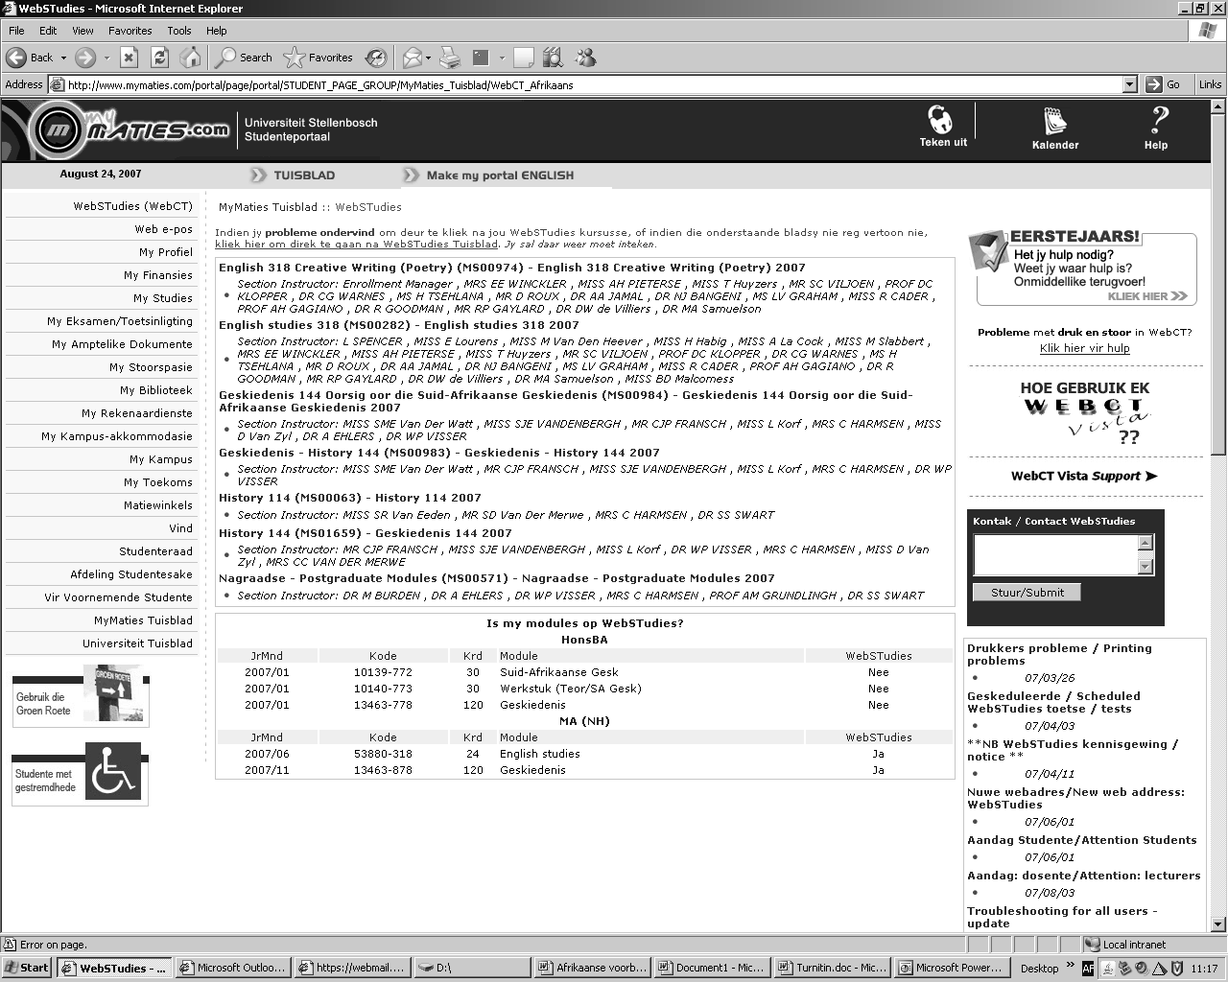

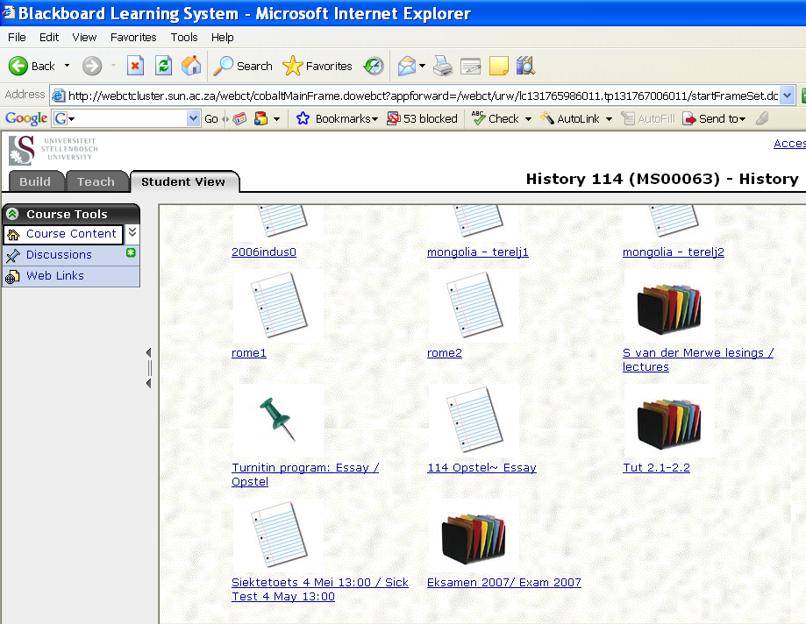

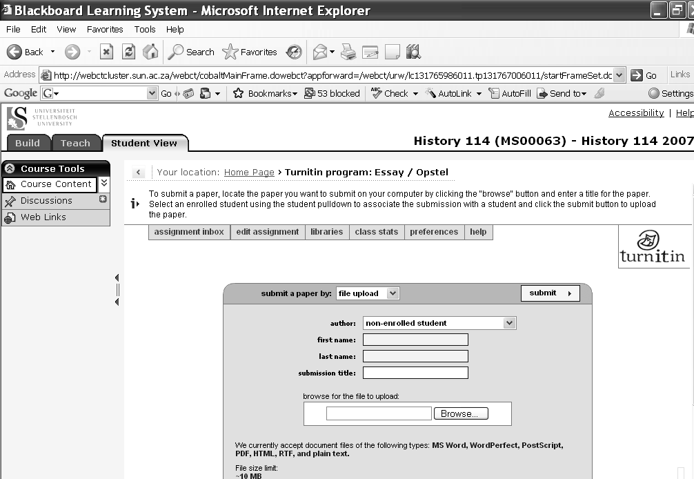

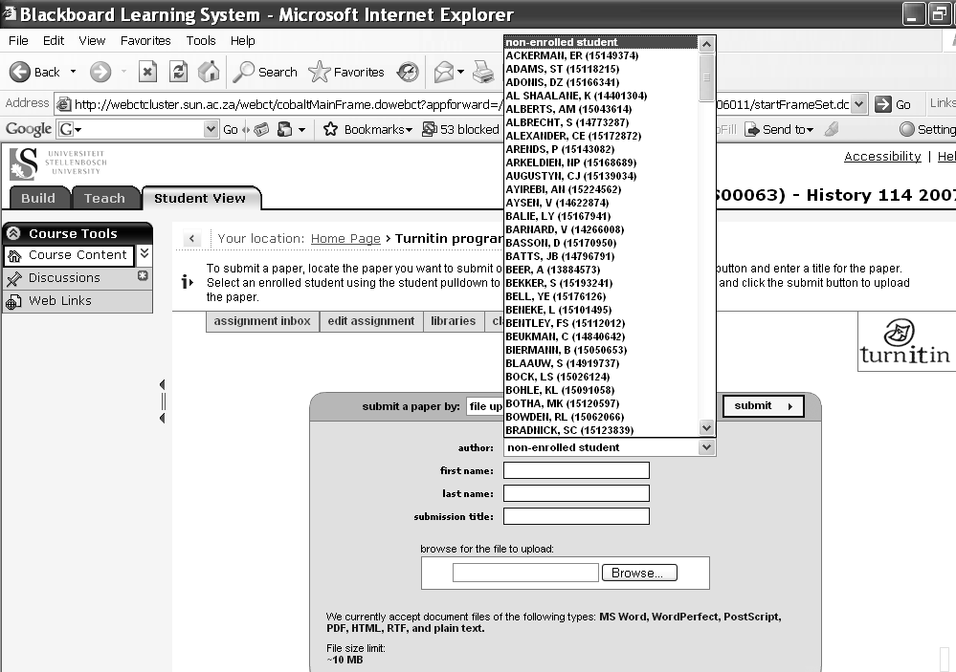

Step Six
Click the scroll button next to author and scroll down to your name.

(Surname, initial, student number)

Please Note:
If you cannot find your name go to the history secretary immediately.

Step Seven
Type in the title of your history essay
E.g.: The rise and fall of the Roman Empire

Step Eight
Click on the “Browse” option

Step Nine
Locate your essay (click on your essay file and then click “open”)

Please Note:
You can only enter your essay onto Turnitin once. Therefore you must ensure that you enter the correct essay. If you make a mistake, do not leave it – go to the Departmental secretary.

Step Ten
Click on the “Submit” button

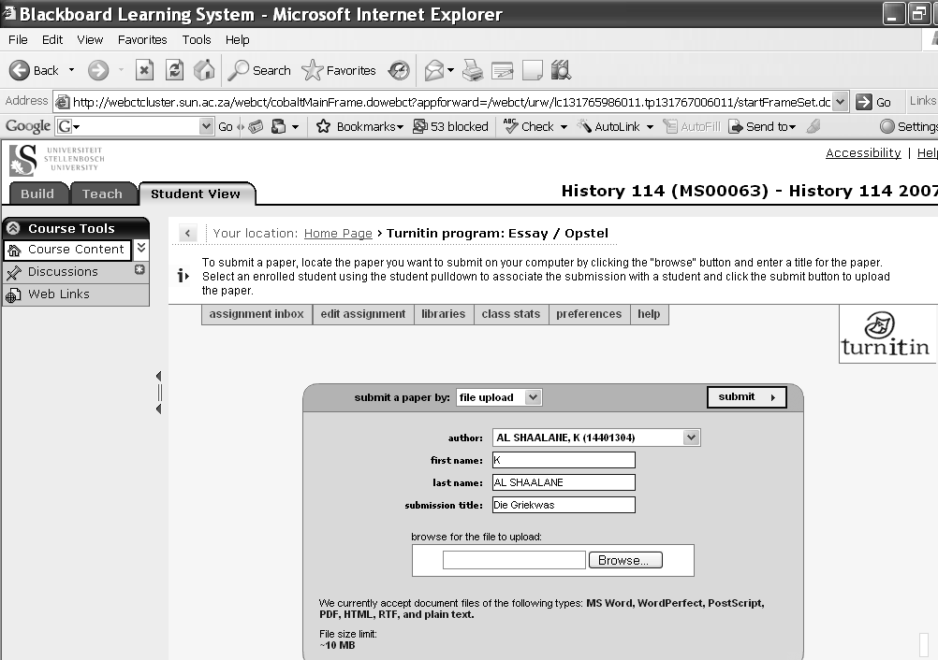

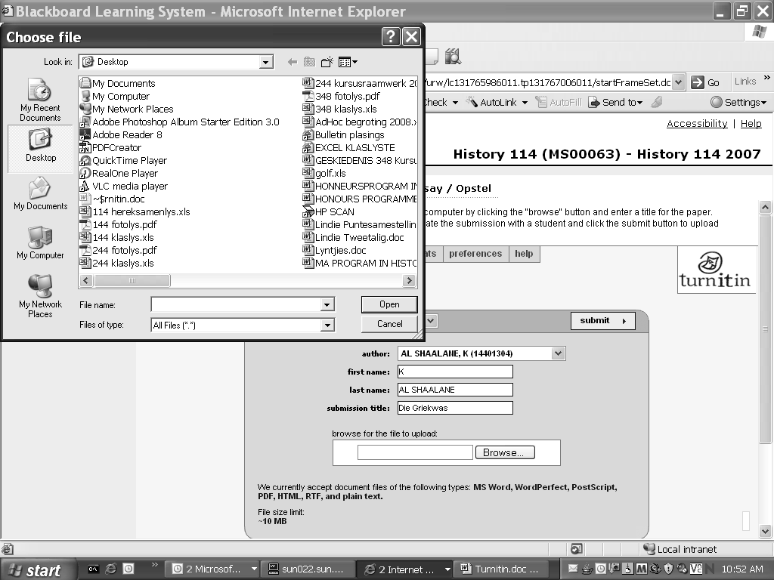

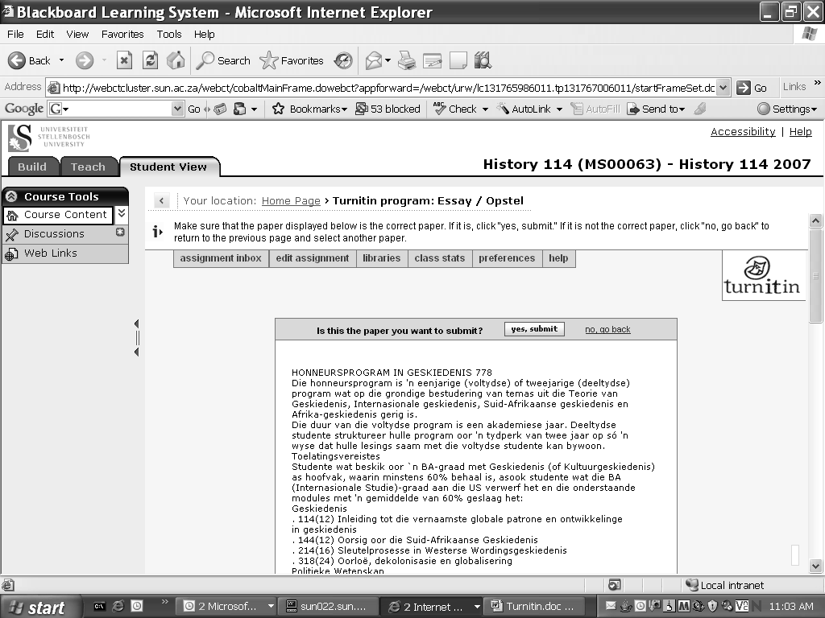

Step Eleven
Your essay will be opened by the Turnitin program. If you are satisfied that you have selected the correct file (essay) click “yes, submit” – if you would like to change the file click on “No, go back”

Please Note:
The format (font, font size, margins etc.) changes in Turnitin – this is normal.

Step Twelve
Having submitted your essay through Turnitin you need to print a “Turnitin Receipt.” This receipt shows that you have submitted your essay successfully, as well as the date of submission.

You must print this receipt and attach it to the hardcopy of your essay. Sometimes the entire essay is printed, you need only attach the first page (see left) with the Turnitin information on it.

Please Note:
A Turnitin receipt is not the hardcopy of your essay, you must hand in a hardcopy of your essay with the correct formatting etc. (see section D).

Please Note:
You will not see the breakdown of your essay by the Turnitin program, this is confidential and seen by your tutors/lecturer. This is an example of what a tutor might see, note how the program locates plagiarism from internet pages, past papers and published works.

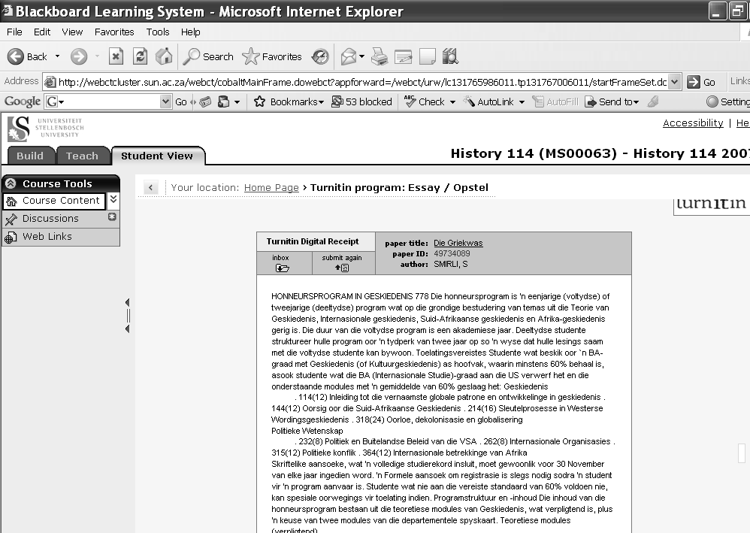

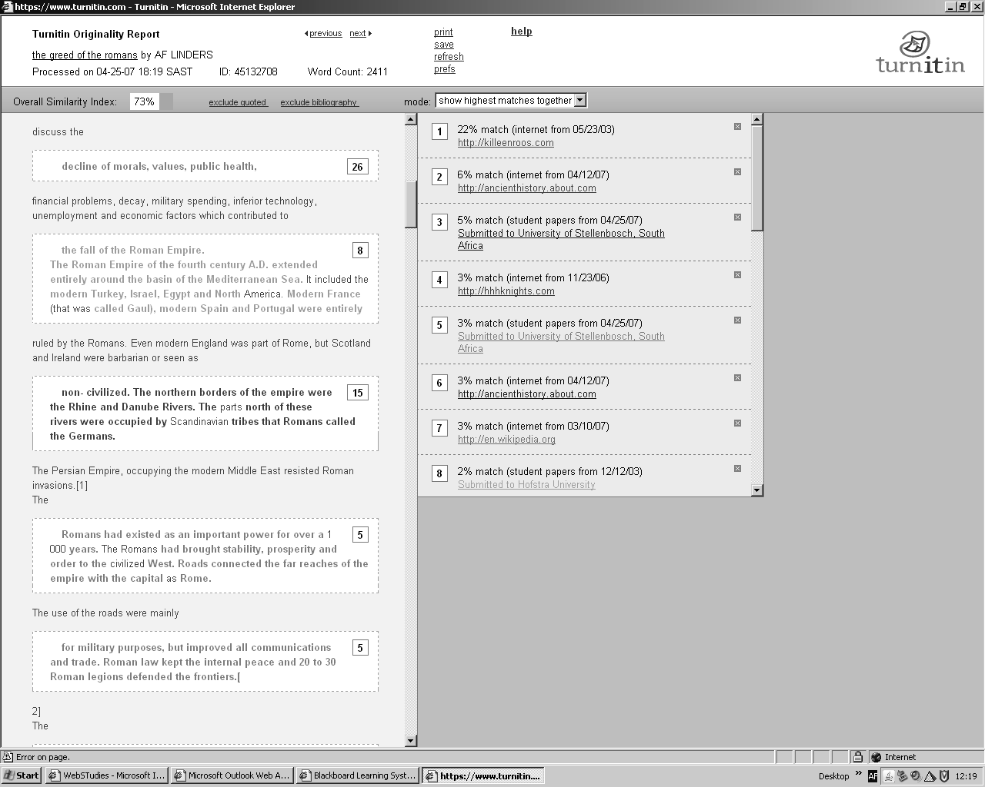

- Departmental Plagiarism Form

Students must also attach a signed plagiarism form to their essay. This form can be found on WebCT. Student’s must use the plagiarism form from the History Department when handing in a history essay. Student’s must sign and date this form accordingly, in so doing student’s declare that they have not plagiarised. An essay without a plagiarism declaration will be heavily penalised. This form is available in both English and Afrikaans. Please note that is unnecessary to hand in both the English and Afrikaans form – one will do.

Plagiarism Form for the History Department: To be printed off WebCT
SUBMISSION DECLARATION

UNIVERSITY OF STELLENBOSCH
DEPARTMENT OF HISTORY

I ………..………………………………………………………………………......
Student No ………………………………………………………………………...
Module………………………………………………………. ………………….

hereby acknowledge that I understand what plagiarism entails and that I am fully aware of the University’s policies regarding plagiarism. I affirm that this assignment is entirely my own work. I have acknowledged and referenced all sources, including internet websites. I agree that if plagiarism is suspected, that my assignment will immediately become subject to a departmental review process. I understand that if I am found guilty of plagiarism, I am liable to face disciplinary actions as detailed in the Department of History’s Policy on Plagiarism and Referencing, and that if the matter goes to an University Disciplinary hearing, this will necessitate my facing other disciplinary action as governed by University rules or even lead to my expulsion from the University.

Signature: ______________________________

Date: __________________________________

In the case of e-assignments (WebCT), this Declaration will be included with the instructions.

Submission checklist: I also state that I have:

- I have submitted my essay through Turnitin and attached the receipt to my essay. 
- I have not made use of a translation programme. 
- Attached a full list of references in my bibliography 
- Inserted page numbers 
- Made a spare hard copy and saved the assignment electronically. 

Insert your full name and surname
Insert your student number
Insert module e.g.: history 114

You must sign your plagiarism form

Please write the date that you signed the document

Tick the relevant boxes

Attach the plagiarism form to your essay.

Test Yourself
- What is plagiarism?
- What are the penalties of plagiarism?
- How can you ensure that you do not plagiarise?
- What is Turnitin?
- What are the two forms regarding plagiarism that must be attached to your essay?

Vocabulary: Words you should understand

Protocol
Noun 1 The system of rules on the correct or acceptable way to behave on official occasions.

Verbatim
Adjective 1 Repeating the actual words that were spoken or written.

Annulled
Verb 1 To state that a legal agreement no longer exists.

Deadline
Noun 1 A date or time by which you have to do or complete something

Section C: Referencing

The History Department at Stellenbosch requires students to use the Chicago method for referencing. Students should not confuse this with other referencing methods like MLA (favoured by the English Department) or the Harvard method. The Chicago Method is seen as the best referencing system for history essays and differs from other referncing methods in that it uses footnotes. The MLA and Harvard referencing methods use in-text referencing (i.e.: the reference will be inserted into the text, usually in brackets). The Chicago Method uses footnotes and thus referencing does not interrupt the flow of the argument. Referencing is very important because it guards against plagiarism and enables the tutor/lecturer marking a student’s essay to gauge how well a student is integrating sources, backing up their argument with valid academic sources, and so on. At first year level a large portion of an essay mark is dedicated to correct referencing, thus students must ensure that they have a handle on the Chicago Referencing Method before they submit their essays to avoid losing marks unnecessarily.

Please Note:
The Chicago Referencing Method requires footnotes (referencing the use of sources throughout the essay) and a Bibliography (a list of all references used in the essay). Students will note that the format for referencing sources differs between footnotes and the bibliography.

Inserting a footnote

When typing your essay (an essay must be typed) students are most likely to use Microsoft Word. Older versions of Microsoft Word differ slightly to the newer version found on University computers. In the older versions students will insert a footnote by clicking on “insert”, scrolling down to “reference” and selecting “footnote.”

Inserting a footnote on MS Word

Inserting a footnote on older versions of MS Word

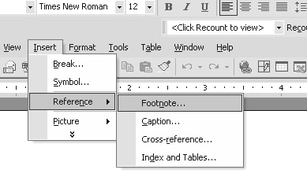
Students must make sure they select “footnote” and not “endnote”, a footnote is found at the bottom of a page whereas an endnote will place itself at the end of an essay/document.

Students must ensure that they use continuous numbering.

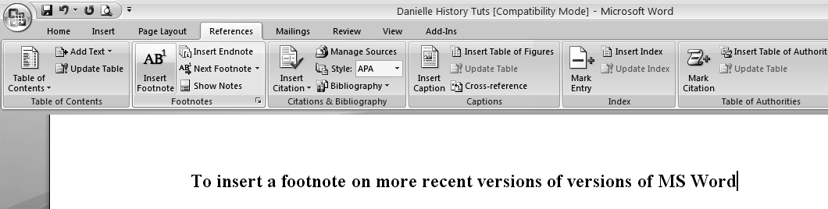
To insert a footnote on more recent versions of versions of MS Word
In Word 2007 (the version found on new and campus computers) to insert a footnote students must go to the “References” menu and click on “Insert Footnote”

Footnotes

If a student successfully inserts a footnote their cursor will move to the bottom of the page. Students will notice that a small number will appear in the text where they inserted a footnote and a corresponding number at the bottom of the page (where their cursor should now be). Students will then insert the reference (see reference format in next sub-section) and, having completed the reference, students will click on their main text and continue writing. Footnotes are inserted after the punctuation mark, or the full stop, of a sentence.

The format of footnotes

Students must pay careful attention to their footnotes – making sure that every dot is in the right place before they hand in their essays.

Please Note:
Page numbers
Students must always insert the page number(s) in a reference. Students must not use the shortening “pg” for page but p. and pp. Note that there is a character space between p. or pp. and the page number (i.e.: p. 7. or pp. 9-10.)
p. = One page
pp. = More than one page.
Ibid.
If the source referenced is the same source as the previous one, use Ibid. The first reference on a page must be written in full and not Ibid. – even if it is the same source as the last reference on the previous page. Note that Ibid. is in italics and followed by a full stop. Ibid. is also used when the same source but different page is referenced
J. Lough: An Introduction to Eighteenth Century France, p. 103.
Ibid.
Ibid. pp. 95-104.
4
5
6

Type of Source | Reference Format: Footnotes | Example
Books | Initial(s). Surname: Title in italics, page number(s). | V. de Waal: The Politics of Reconciliation: South Africa post-Mandela, pp. 29-32.
Books with an editor | Initial. Surname (ed.): Title in italics, page number(s). | C. Saunders (ed.): Illustrated History of South Africa – The Real Story, p. 106.
Journal Articles | Initial(s). Surname: “Title of article in quotation marks,” Title of Journal in italics, (Vol.), (No.), (date), page number(s). | K. L. Harris: “‘Accepting the group but not the area’: The South African Chinese and the Group Areas Act,” South African Historical Journal, (40), May 1999, p. 181.
Newspaper Articles | Initial(s). Surname: “Title of article in quotation marks,” Title of Newspaper in Italics, date, page number(s). | B. Louw: “Chinese lured by freedom into Africa,” Daily News, 12 December 2006, p. 15.
Encyclopaedia | Encyclopaedia volume, Heading of the used Section in italics, page number(s). | Collier’s Encyclopaedia vol.10: torture in the Middle Ages, p. 398.
Internet Sources | The URL (date downloaded).  Or, if information is available:  Initial(s). Surname: name of webpage in italics (date downloaded). | http://www.sun.ac.za/history  (20 February 2006).  C. Smith: The Greatest love story ever told (7 June 2007).
More than one source used for an idea | Source 1 & Source 2. | D. A. Mungazi: Colonial Policy and Conflict in Zimbabwe, p. 6. & A. J. Wills: An Introduction to the History of central Africa, p. 134.

When to insert a footnote

Students should note that they must insert a reference (footnote) whenever they use a source – whether quoting, paraphrasing, or using a fact or statistic. Students do not have to reference every single sentence if they have used the same source, they need only reference when they have stopped using one source and moved onto another (i.e. If a student uses the same source for three sentences then they insert the footnote at the end of the third sentence, if they then use the next source for one sentence they insert that source’s reference at the end of that sentence). Students must note that they do not only reference when they quote or reference once a page, students should reference at least once a paragraph. If a student has only one reference or source per page of writing it is likely that they are not integrating their sources adequately. Remember, a history essay uses evidence to support an argument and is not simply a summary of a source.

Notice the referencing in this (fictitious) example:

When Joe Soap was a boy he worked at the local grocery store where he built tall towers out of tins, approaching the tedious chore of stacking tinned fish with creativity. Little did the townspeople know that the young Joe Soap would grow up to design some of the tallest buildings in the country. As historian Joseph Miller remarked, “Soap was a country bumpkin, but his humble roots only made his fantastic accomplishments all the more astounding.” Soap’s father always believed in his son and took a second job so that the young Soap could attend a finer school in the next town. Soap was thrilled, but quickly came to dislike the school as he was bullied by a group of older boys – coming home with a black eye and torn shirt on more than one occasion.

Bibliography

Students must remember to have both footnotes and a bibliography. In a bibliography students can only list sources that they have used in their essay. If students insert sources that have not been referenced in their footnotes they will be penalised. As such, books that students have read but have not used directly (using facts or statistics, quoting summarising or paraphrasing) cannot be included in the bibliography.

Important rules regarding bibliographies

- The bibliography is at the end of an essay on a new page.
- Sources must be listed alphabetically (from A-Z) according to the author’s surname.
- Sources must not be numbered or bulleted.
- A single line should be left open between sources.
- Sources must not be in bold.
- The bibliography must be typed in the same font as the rest of the essay (Times New Roman, size 12, 1.5 spacing, justified margins).

Type of Source | Reference Format: Bibliography | Example
Books | Surname, Initial(s): Title in Italics. Publisher, place, year. | Behrens, V. B. A.: The Ancien Régime. Thames and Hudson, London, 1967.
Books with an editor | Surname, Initial(s) (ed.): Title in Italics. Publisher, place, year. | Metcalf, J. (ed.): Illustrated Oxford Dictionary. Oxford University press, Oxford, 1998.
Journal Articles | Surname, Initial(s): “Title of article in quotation marks.” Title of Journal in italics, (Vol.), (No.), (year), page numbers. | Harris, K. L.: “‘Accepting the group but not the area’: The South African Chinese and the Group Areas Act,” South African Historical Journal, (40), 1999, p. 181.
Newspaper Articles | Surname, Initial(s): “Title of article in quotation marks,” Title of Newspaper in Italics, date, page number(s). | Louw, B.: “Chinese lured by freedom into Africa,” Daily News, 12 December 2006, p. 15.
Encyclopaedia | Title in italics. Place, year. | Encyclopaedia Britanica. Chicago. 1967.
Internet Sources | The URL (date downloaded).  Or, if information is available:  Initial. Surname: name of webpage in italics. URL. (date posted or date downloaded). | http://www.sun.ac.za/history  (20 February 2006).  C. Smith: The Greatest love story ever told http://greatromances.com/twentiethcenturyromeo (7 June 2007).
More than one author/editor | Surname, Initial(s). & Surname, Initial(s): Title in italics. Publisher, Place, Year. | Higham, J. & Conkin, P. K. (eds.): new Directions in American intellectual History. The John Hopkins University Press, London, 1980.

Section D: Writing History Essays

Please note: This section should be used in conjunction with the slides on essay writing found on WebCT

Writing a well structured academic essay is crucial to any module, subject or course in the Arts and Social Sciences. Essays are the best means of testing a student’s understanding of, and development in, a subject. The main means of testing, essays also develop the ability of students to research, internalise and organise large amounts of data into clear arguments. The most important thing that students need to bear in mind when approaching an academic essay is that they are communicating an idea or argument. This means that everything in their essay and the way that it is presented must serve this communication (i.e.: a well written and structured essay will communicate an argument better than a poorly structured essay; a neatly typed essay will be easier to read than one that is handwritten, and so on).

In the History Department essays are marked using a rubric and the tutor/lecturer details areas that require improvement. Students are encouraged to adhere to this advice and are welcome to discuss their essays with their tutors (before and after the essay deadlines) if they have any problems. Students can also make use of the SU writing lab. Students can write in English or Afrikaans as is their preference, although they are advised to write in the language in which they are most proficient. Students must note that they may only write in one language in an essay and may not use Afrikaans and English interchangeably. Whether writing in their second language or their mother tongue, students must check their grammar, spelling, and vocabulary thoroughly. It may be helpful for students to ask a friend to read over their essays and check for any mistakes.

Choosing a question

The first thing that a student needs to do is choose an essay question/topic. These are chosen by the lecturer and are either included in the module reader or put onto the module board (located in the history department, third floor of the Wilcocks). Students may request permission to do their own topic, however they must receive permission from the lecturer and it must be pertinent to the module. Students should also bear in mind that essay questions set out by the lecturer are based on available material in the University library and academic journals. When choosing a question, students should try to choose one that interests and challenges them. This interest will show in the amount of effort that a student puts into their essay.

Having chosen a question, students must make sure that they fully understand the question. There is a difference between question and topic:
Topic = refers to the historical subject in a broad sense
Question = refers to a particular aspect of the historical subject
For example, an historical topic could be the Industrial Revolution whilst the question could ask about children in the Industrial Revolution. As such an essay that responds to the question of children in the Industrial Revolution cannot detail the revolution only, or concentrate on the use of machinery in the period – whilst covering the topic an essay must also answer the question. Students must thus ensure that they understand what the topic of their essay is and what the question of their essay is. By separating the two students may get a clearer notion of what is required of them.

Having chosen a question and making sure that they understand that question, students will need to do research. Generally students will begin by conducting broad research – for example a quick Google search or a selection of books on the essay topic – to get a clearer indication of what their topic/question entails. Students can then narrow down their search, going from topic to question. Students may choose to approach their essay question from a particular angle (for example: women’s history, cultural history, political history) and thus will narrow their search from topic, to question, to angle. Students must ensure that they have enough sources (i.e.: that they are above the minimum requirement) and bear in mind that they are required to integrate sources. This means that they must not depend on one source or two sources for the bulk of their information but read widely and critically.

Planning

Students must plan their essays, a well structured essay is key to a clear argument and a good mark. Planning an essay entails drawing up a rough plan of how an essay will unfold, what information will go where, and so on. Even though the final draft of an essay may look quite different from the planned essay, planning is important because it makes a student think through their information and argument more thoroughly. Often students will find that they are required to do more research for areas that they had neglected and planning is the best way to spot weak areas. In planning their essays students must make sure that their proposed argument and information answers the question.

As in journalism there are five crucial questions that a history student must answer: Who? What? When? Why? Where? In making sure that they can answer these questions by the planning stage (after research) students can make sure that they have researched thoroughly enough and internalised the information adequately. Students can make use of these questions whilst brainstorming/planning their essays and use these questions to approach their essay topic/question from different angles.

Who?
Students must make sure that they know the characters involved in an event – from individuals to groups. This question should cover anything from the biographical information of an historical figure to the motivating factors of a class movement, depending on the “who” of the question.

What?
Remember that there are many accounts for the same event or topic as there are different opinions regarding just what happened or what something is. Students should ensure that they know the different accounts and include them in their essays where necessary. This is especially true of a question that requires a student to take a position as counterarguments should be included.
When?
Students must remember that “historians analyze change and continuity over time,” this means that they need to know when something happened. Where possible, students should include the dates (at least the year) of when something occurred, even if the date is a well known one. If students do not know the date they should not attempt to guess the date, generally no date is better than the wrong date. Students should also try to write chronologically so that the points unfold in a logical manner and the reader has a clear sense of how the historical event unfolded.
Why?
This is a very important question as it covers the arguments as to why something did or did not happen. Often this will form the bulk of a student’s answer as it requires them to show the various causes or factors which enabled something to happen, or prevented it from happening.
Where?
Students need to contextualise events and therefore need to show where it happened. Sometimes this may seem unnecessary – for example “the South African War (1899-1902) occurred in South Africa” is probably better written as “The Anglo Boer War, often referred to as the South African War, was fought on South African soil from 1899 to 1902.” There are ways around obvious redundancy and students will learn to negate what is and is not necessary. It is important to contextualise where and when an event occurred so that the reader can place it geographically and temporally. Students must remember not to simply assume that their reader knows what they are talking about, they should write as though their audience is their peer who has little knowledge on the topic and not for their lecturer or tutor.

Structure

Academic essays have a straightforward structure that can be divided into three parts – Introduction, Body, Conclusion. This structure is the same in just about all subjects in the Arts and Social Sciences (the difference between subjects comes in the type of research and the use of sources). Students are expected to follow this structure closely and must always ensure that they have a functional introduction and conclusion.

Introduction

The introduction is the first impression a reader has of an essay. It is in the introduction that the reader learns what the essay is about, what is argues and how it argues this. As such the introduction can be said to be a statement of intent, a paragraph that briefly answers the Who? What? When? Why? Where? of the essay topic, question, and argument. Students should begin the introduction by catching their reader’s attention and introducing their topic in an inviting way. However, students should avoid over dramatic statements or overly florid writing – never using “Once upon a time” or “One day” and so on. Students must also note that when stating what the essay argues students must not use “I” but “this essay” (i.e.: “this essay evaluates” rather than “I evaluate”). The length of the introduction depends on the length of the essay. At first year level an introduction will be one good paragraph, longer essays will have an introduction of two or three paragraphs. This is because the longer the essay the more the essay covers, and thus the more that the introduction will need to detail.

As such an introduction:
- Introduces the reader to the topic in an inviting way (setting the scene)
- Draws the reader’s attention to the problem at hand
- States argument/intent of the essay
- States how the essay goes about proving this argument

Body

The body of an essay is made up of paragraphs that build logically onto one another in a clear, well-structured essay. Paragraphs can be said to be the building blocks of the essay. Each paragraph deals with a point in an argument (one point per paragraph). In terms of length a paragraph is at least three or four good sentences long (a sentence is usually 1.5 lines long). Where possible students should avoid overly long sentences and paragraphs. If sentences or paragraphs are too long they can lose their focus, diminishing their impact and the focus of the essay in general. Broadly speaking paragraphs have a basic structure – the first sentence is a statement (sometimes called a “topic sentence”) that is backed up by the sentences that follow it. The number of paragraphs in an essay depends on the length of the essay as well as how the student chooses to structure their essay. A well structured essay will have paragraphs that flow logically from one to another. Students must ensure that they write chronologically, so that each point is placed in historical context. In order to keep the focus of the essay intact, students may wish to draw the reader’s attention back to the question/argument every so often (student’s must judge whether or not this is necessary).

As such the body
- Is made up of paragraphs that follow logically and chronologically
- Each paragraph deals with a point in the argument
- Together these points build an argument (stated in the introduction)
- The body is where the content of the essay is found.

Conclusion

An essay must always have a conclusion as it ties the essay together. This is done through a brief summary of the essays main points and then how these points prove the essay’s argument. A conclusion should be one good paragraph long and should avoid clichéd endings involving how “this was a really bad thing!” or how “the world is a much better place now!” Generally speaking if a reader were to read only the introduction and conclusion they should be able to know exactly what is in an essay and what it argues.

As such, the conclusion
- States what the essay has argued
- Sums up the main points of the essay body
- States how this evidence supports essay’s argument
Summary of Essay Structure

Introduction
States the argument of the essay and how the essay argues this (body outline)

Body
Provides the evidence for the argument in clear, well structured paragraphs

Conclusion
Shows how the evidence provided in the body of the essay supports the argument stated in the introduction of the essay.

Quoting

Students may make use of quotes in their history essays, although they should do so with some caution. Students must be careful of quoting too much and must remember that the tutor/lecturer wants to read the writing of the student and not just quotes. Too many quotes will result in severe penalties. As a rule of thumb students should quote when they cannot summarise or paraphrase. Students may also choose to quote a particular viewpoint that gives atmosphere to their essay (for example a speech or firsthand account of something).
Students should be wary of quotes that are too long, long quotes should be the exception rather than the norm. There is no clear standard for what counts as too many quotes as it depends on the essay, students will learn what is and is not necessary to quote (for example there is no need to quote “three hens, six donkeys and nine horses were in the yard” rather paraphrase - In the yard they found many animals – including nine horses, three hens and six donkeys - followed by the reference). When quoting students may not change the spelling or grammar of the text and must not quote ambiguously (altering the quote to suit their own purposes). Students must also format the quotes according to their length:

Short Quotes (up to three lines long)
Short quotes do not to be formatted; they need only have “quotation marks” and a reference. Students must ensure that they insert quotation marks accurately. There is also no need to insert ellipses dots before and after a …”quote”… These are only used when words are left out in a quote (e.g.: “Jack and Jill…the hill”). Square brackets are used when inserting words into a quote (e.g.: “Jack and Jill [fell from] the hill”)
Long Quotes (four lines and longer)
Long quotes need to be formatted by adjusting the margins and the line spacing. This is to make it easier for the reader to discern between the quote and the student’s writing.

Example of a long quote formatted

“To format a long quote, adjust the margins of the quote so that they are narrower than the main text. Also adjust the spacing of the quote so that it is single spacing and not 1.5 line spacing like the main text. This is to ensure that the quote stands apart from the main text. Students must not forget to insert a reference at the end of the quote. Students may remove the quotation marks when the quote is formatted like this (providing they are consistent and that all long, formatted quotes follow the same format).”

How to format a quote on MS Word

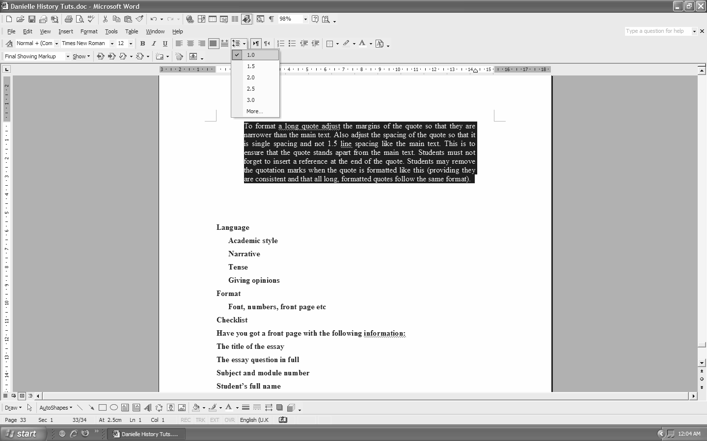
Change line spacing to single spacing (not 1.5 spacing)
Change margins, making them narrower than the main text.

Section E: Language

The way that an academic essay is written is very important. Essays must be written in formal language and not colloquial language. This does not mean that student’s need to write in a “boring” tone or that they need to employ complicated terminology. Formal language means that the writing style should be straightforward rather than literary, that the narrative should be clear and devoid of slang and clichés. Students may not write that “Smith hailed from a small town” or that “Napoleon was not really a cool guy” but that “Smith came from a small town” or “Napoleon was not known for his friendly demeanour.”

Although students should try to broaden their vocabulary they should not employ words unless they are fully aware of their meaning. Misused words create confusion and ambiguity, damaging an essay. As such students need to be wary of the tone and style of their writing, they also need to remember that they are writing an historical narrative and not a piece of creative writing or a letter to a friend. Students must also pay strict attention to their tenses, making sure that they use a consistent tense and do not swap between past and present tense accidentally. When writing their essays students should imagine that they are writing for a peer (someone their age) who is intelligent but does not know about the subject. Students should not write specifically for their tutor or lecturer. By imagining that they are writing for a peer, students will have a clearer indication of what to include and what to leave out.

Students must note that they may not refer to themselves in the first person in their essay, i.e.: they may not use “I”. If they must refer to themselves students should use “one” – “one can see that” rather than “I can see that...” On the whole, students are advised to avoid referring to themselves and if they must to do so in the conclusion (for example, if asked for an opinion). Students must bear in mind that they need to try be objective, and using “I” and referring to oneself usually makes something subjective. Students should avoid giving opinions when an opinion is not asked for, bearing in mind that they need to make an argument (i.e.: Argue their opinion in a formal, academic manner) rather than an “I think” answer. Students should also avoid making sweeping statements, generalisations or assumptions without evidence.

Important rules regarding language in Academic Essays

The following rules must be obeyed in writing an academic essay. Students will be penalised if they fail to comply with any of these language rules.
- Do not use colloquial language e.g.: “cool”, “hailed from”, “ok”, “kind of” etc. Formal academic language must be used.
- Whilst students should avoid colloquial language they should also be careful of using words that are antiquated or obscure. This often happens when students use the thesaurus on their computers, students must remember that a thesaurus gives similar words (similar does not mean that the word has the same meaning) – so students should fully understand a word before they use it. The same rule applies for theoretical terms, students should be wary of employing theoretical concepts without knowing what they imply.
- Do not use contractions these are informal – e.g.: “don’t”, “couldn’t”, “can’t” etc. Students must rather use “do not”, “could not”, “cannot”, and so on. Students may not use short form like etc. instead of etcetera, e.g. instead of example, i.e. and so on.
Students must remember that if they are quoting they must not change the language of the quote, so if the quote has contractions and informal language this must not be altered.
- Students should try to be politically correct where possible. Often students will come across words that are politically incorrect – these can be used (if they aid the essay) but must be placed in inverted commas, e.g.: “kaffirs”, “coolies”, “fags”. When being politically correct students must also be sensible, this is particularly true of gender. If a student is talking about a society of people (both male and female) then they should refer to a society of “men and women” and not just “men” and they can also say “he or she.” However, if a student is talking about a something that is gender specific then the politically-correct “men and women” or “he or she” becomes redundant (for example, it makes no sense to say “he or she might give birth without a doctor”). In order to know what is appropriate a student needs to know what they are talking about, so using politically correct language incorrectly can make students look inept.
- Avoid using “I”, “me”, “my”, “you”, or “we”. There is a fashion to write as though one is on an adventure of discovery with the reader, e.g. “let us now look at,” “as we soon discover” and so on. Students should maintain a formal tone and not overuse this style, in general students should avoid referring to themselves.
- When first referring to another author or historical figure both their full name should be used, e.g.: Emily Hobhouse. Thereafter they can be referred to by surname only, “Hobhouse”. Students do not need to refer to people as Mr, Mrs or Miss.
- Students must watch their tenses, if a person is still alive they should be referred to in the present tense, e.g.: “Kim Smith asserts that...” However, if a person is dead then they should be referred to in the past tense, e.g.: “Jim Jones asserted that...”
- Do not use apostrophes for decades, i.e.: 1950s not 1950’s
Please note: In Afrikaans apostrophes are still used (1950’s).
- Write “sixteenth century” rather than “16th century”
- Students should be descriptive but should not go overboard. For example, “he was a really nasty, awful person with a mean temperament” is overly descriptive. This can be toned down to “he was remembered as someone with a mean temperament.”
- Be specific – rather than referring to something as “this” or “that” students should refer to the thing itself. For example, instead of saying “this was really important for the party’s future,” students should say “this change in direction was important for the future of the party.” For this reason students may not use “etcetara” or etc. in an essay.
- Students should avoid using exclamation marks (!!!!!)
- In a test students will underline what they would place in italics on the computer. So titles of publications will be underlined in a written test and placed in italics when typed on a computer.
- Titles are capitalised if they are attached to a name, e.g.: “Prince William” and “the prince walked into the hall and greeted James.”
- Students must always go through their work and check their spelling, grammar and punctuation.
- Students should note that it is “a history” but “an historian”. Students should remember “an historical account is a history written by an historian.”

Section F: Essay Format

Essays have a very strict presentation and format, students should note the following requirements:

Cover Page
All essays must have a cover page with the following information:
The title of the essay
The essay question in full
Subject and module number
Student’s full name
Student number
Lecturer’s name

Contents Page

Some lecturers require a contents page, students must note the requirements of each lecturer (for example, some lecturers require subsections whilst others do not allow subsections).

Format

There is a specific format given because often essay length is given in pages rather than word count. As such a single format is used to ensure that all students write the same amount.
The font must be Times New Roman
The font size must be size 12
The text must be written with 1.5 line spacing
The essay must have justified margins
There must be page numbers

Pictures and decorating work

Students may not use pictures or decorate their work. As such, cover pages should not have pictures or frames, essay pages should not have borders and pictures should be avoided. Sometimes a picture is necessary, for example if a student is discussing the Mona Lisa with reference to the content of the picture then a picture is necessary, however a picture of Napoleon is unnecessary when discussing the life of the man. if a student does insert a picture they must reference it and contextualise it properly. On the whole students are advised not to include pictures, and students should discuss the use of pictures with their lecturer or tutor before submitting an essay.

Presentation

Essays must be typed in black ink, and a hard copy must be handed in (essay box located in the history department). Students must ensure that their essay is stapled or bound properly and that the pages are in the correct order, and that the signed plagiarism form and Turnitin receipt are attached to the essay. Essays bound by a hair clip or any other inventive measure will have marks deducted for sloppiness. Students may not borrow a stapler from the history secretary.

Deadlines and Late Submissions

Students must make sure that they know the deadline of their essay and ensure that they run their essay through Turnitin and hand in a hardcopy of their essay before the deadline. The penalty for late submissions is a deduction of 10% for the first day late and 5% each day thereafter. If a student has any problem regarding an essay or the deadline they must speak to the lecturer or tutor as soon as possible.

Test Yourself:

- What is the difference between topic and question?

- What is the value of planning?

- What are the three parts of an essay and what are their functions?

- When writing an essay for whom should a student write? Why?

- List ten rules regarding language in academic essays.

- What is the difference between long quotes and short quotes in terms of formatting? Why?

- What are the five questions historians need to ask?

Vocabulary: Words you should understand

Chronological
Adjective. 1 (Of a number of events) starting with the earliest and following the order in which they occurred. 2 Relating to the establishments of dates of past events.
Derivatives: chronologically (adverb)

Colloquial
Adjective. 1 (Of language) used in ordinary conversation; not formal or literary.

Antiquated
Adjective. 1 Old-fashioned or outdated.

Section E: Tests and Exams

Section G: Tests and Exams

Preparation for tests and exams
Always attend lectures and take notes in class

The lecturer will often highlight the aspects of the coursework considered to be most important and thus most likely to be tested. As such, making notes in class will help provide students with a point of focus when making summaries. It is advisable that students regularly compare their class notes to the setwork long before the test or exam. This will prevent students from becoming overwhelmed the week before a test, as well as give them the opportunity to ask questions about elements of work on which they are unclear before a test.

Make summaries

A summary provides a shorter version of the coursework, highlighting the most important aspects. Summaries also require students to put the work into their own words, this requires understanding and is thus a good way of learning the work. By summarizing students are more likely to internalize and fully understand the course content and are therefore more capable of developing an informed argument.

Hi[story]: using mnemonics and other techniques to learn

Remember that history is a story with a factual and chronological development. It may help the student to learn the work in such a way that they can repeat it as if telling a story to a friend. Students should remember that historical events do not occur in isolation. Like any story historical events have causes and consequences that shape the way in which it is viewed. Historical accounts have more than one point of view and may be interpreted in different ways depending upon the argument being made. However, unlike telling a simple tale or narrative of interest, it is essential that a student is accurate with the facts and dates. Students should not guess dates, instead of guessing a random date students should refer to the period or century. Within reason no date is better than a wrong date (but a correct date gets a higher mark).

The large amounts of information that a student needs to learn means that they may benefit from using certain mnemonic techniques. Mnemonics refers to the techniques used to remember information. Each student may find different techniques better than others. An example of mnemonics includes using acronyms for long lists of information (or even poems and words of association for the more creative). Even if one is preparing an essay question, acronyms may help the student by identifying an important keyword in each paragraph. Many students also find min-maps useful in memorising work as they lay the work out in such a way as to be more visually pleasing and thus easier to commit to memory.

Example of an acronym: remembering the names of King Henry VIII’s six wives and their relative fates

First wife: Catherine of Aragon (divorced)
Second wife: Anne Boleyn (executed)
Third wife: Jane Seymour (died)
Fourth wife: Anne of Cleves (divorced)
Fifth wife: Kathryn Howard (executed)
Sixth wife: Katherine Parr (widowed)
= CAJAKK

To help remember the fate of the various wives, a little poem or sentence may be helpful. For example:
Divorced, beheaded, died,
Divorced, beheaded, survived.

Tests and Exams

Timing

Students must use their time carefully in a test/exam situation. Students should have a watch with them or have a clear view of the clock so that they can keep a close eye on their progress. It may be helpful to divide the test period up according to the amount of questions, allowing for a planning session and perhaps five or ten minutes to proof read answers.
For example, a two hour test period in which two essays must be written may be divided as follows:
15 minutes (planning) + 45 minutes (essay 1) + 45 minutes (essay 2) + 15 minutes (proofing) = 2 hours

Read the Question Carefully

Students must make sure that they read the test/exam question carefully. A five or ten page essay is worth nothing if the essay does not answer the question. Students may find it helpful to break the question down into its various components and ask it the five important questions: Who? What? When? Why? Where?

For example: “The role of blacks in the South African War (1899-1902) has been neglected in history” Critically discuss this statement by looking at the role blacks played in the South African War.

Step 1: Break the Question down

Topic = South African War (1899-1902)
Question a = Blacks in the South African War
Question b = Role of blacks in the South African War neglected in history

Step 2: Ask the five questions (brainstorming)

Students should brainstorm the question, looking at it from various angles as they remember the points that they need to include.

Who?
Who is involved in the South African War? Whites – Boers and British “a white man’s war”
Black people < which black people? < black loyalists, wage workers (British), agterryers (Boers), tribes
Who neglected black involvement? Who ‘re-discovered’ black involvement?

What ?
What was the war about? Was it a ‘white man’s war’?
What does black involvement mean – then? Now?
What did blacks do?

When?
When was the war? When did black people become involved? When was black involvement neglected?

Why?
Why did the war break out? Why did black people become involved? Why were black people not remembered? Why is it important now?

Where?
Where did the war take place?
Where were black people involved? Battle, work, concentration camps, military camps etc.

Step 3: Draw up a Rough Plan

Students can draw up a rough plan on a page on their answer books, they need simply draw a line through the planning and it will not be marked as part of the essay. A rough planning page may look something like this:

Introduction
Introduce topic: South African War (1899-1902) and black involvement, neglected.
Argument: Black involvement was important and was neglected by history until recently.
How is this done: see outline

Paragraph 1: Context < A White Man’s War

Paragraph 2: Black involvement < not allowed
according to rhetoric

Paragraph 3 + 4: Black Involvement < British

Paragraph 5 + 6: Black Involvement < Boer

Paragraph 7: Tribes and fear

Paragraph 8: After the war

Paragraph 9: Neglect

Conclusion
Re-cap main points of argument
Show how these points prove my argument (stated in introduction)

Understand the Terminology: Tests and Exams

Analyse
To carefully describe and discuss something from different perspectives in order to understand it.

Critically Discuss
Discuss something in such a way as to show that you have considered both the good and bad qualities before reaching a conclusion.

Demonstrate
To show or prove something clearly.

Describe
To show what something is like by giving details about its nature.

Discuss
To write something in detail and consider the different ideas or opinions about it.

Examine
To look at something carefully in order to make a decision.

Illustrate
To give an explanation of something using examples that will make the meaning of the argument clearer.

A. Jenkins: The Extraordinary Life of Joe Soap, p. 321.
J. Miller: “The humble roots of a visionary: the early years of Joe Soap, 1912-1976” The Journal of Architecture and History, (3) (6), July 1992, p. 67.
A. Jenkins: The Extraordinary Life of Joe Soap, p. 329.
C. Bloom: Joe Soap: The Dirty Secrets, p. 42.
B. Storey: Writing History, p. 29.
A quote must be followed by a reference (footnote).

